**Network API**

Java Networking is a concept of connecting two or more computing devices together so that we can share resources.

Java socket programming provides facility to share data between different computing devices.

* **Socket Programming :-**

Java Socket programming can be connection-oriented or connection-less. Socket and ServerSocket classes are used for connection-oriented socket programming. DatagramSocket and DatagramPacket classes are used for connection-less socket programming.

The client in socket programming must know two information:

1. IP Address of Server, and
2. Port number

* **Socket Class :-**

A socket is simply an endpoint for communications between the machines. The Socket class can be used to create a socket.

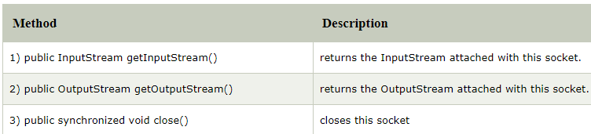

* **Server Socket Class :-**

The ServerSocket class can be used to create a server socket. This object is used to establish communication with the clients.

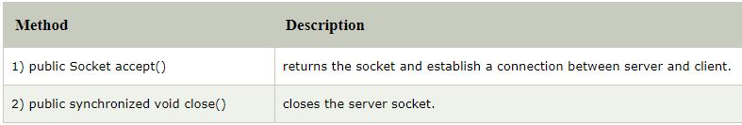

**Example :-**

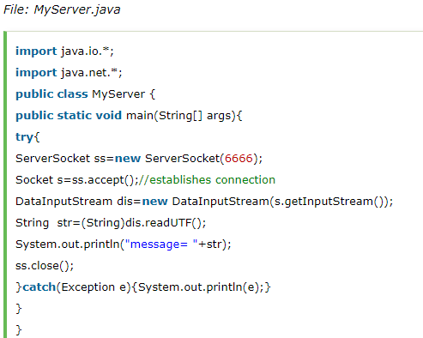

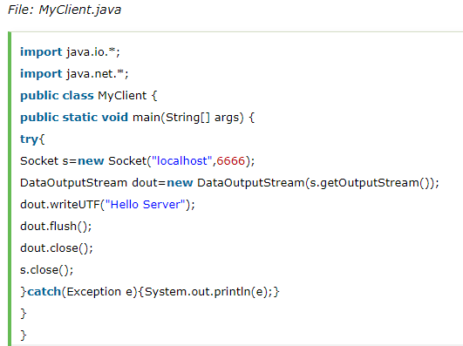

* To execute this program open two command prompts and execute each program at each command prompt as displayed in the below figure.

After running the client application, a message will be displayed on the server console.

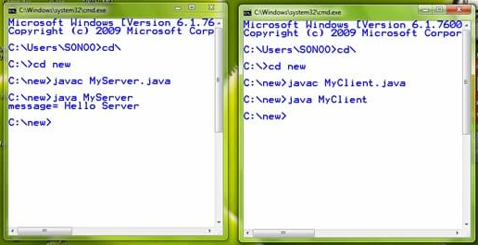

* **URL :-**

The **Java URL** class represents an URL. URL is an Uniform Resource Locator. It points to a resource on the World Wide Web.

A URL contains many information:

1. Protocol: In this case, http is the protocol.
2. Server name or IP Address: In this case, www.javatpoint.com is the server name.
3. Port Number: It is an optional attribute. If we write http//ww.javatpoint.com:80/sonoojaiswal/ , 80 is the port number. If port number is not mentioned in the URL, it returns -1.
4. File Name or directory name: In this case, index.jsp is the file name.

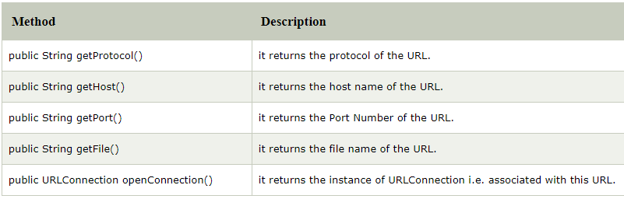

**Example :-**

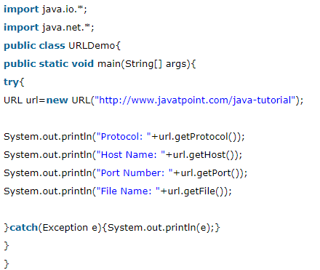

**Output :-**

Protocol: http

Host Name: www.javatpoint.com

Port Number: -1

File Name: /java-tutorial